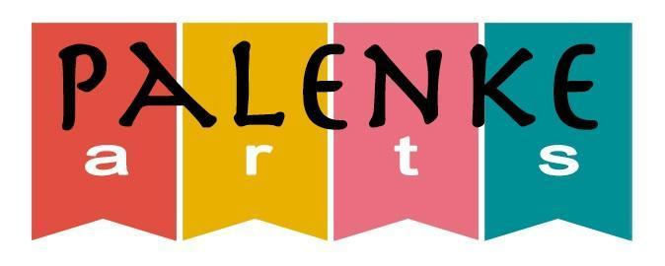
Palenke Arts, 1713 Broadway Ave., Seaside, CA 93955
www.palenkearts.org

When: Sunday, June 4, 2023, 11-4 pm
Where: Laguna Grande Park
1249 Canyon Del Rey Blvd
Seaside, CA 93955

The 7th Palenke Arts Festival is coming back in person to Laguna Grande Park in Seaside! We are again planning a wonderful FREE event full of student and professional performances, children's art activities, live art demos by Paul Richmond and members of The Shop, the Wheelie Mobile, food vendors, art vendors and community booths. Our featured performers are Sambadá the premier Brazilian music band on the West Coast led by Dhanda da Hora that will get us all dancing cumbia, salsa and merengue, Calpulli Tonalehqueh (Mexica dancers), Nā Haumāna (Polynesian dance) and Afrojarocho masters Los Hermanos Vega.
We will also feature our Afro Caribbean drumming program directed by Javier Muniz, our Ballet Folklórico ensembles, the Palenke Arts Dance Crew and Chorus, the Latin Jazz Combo directed by Paul Contos. Our masters of ceremonies will be none other than Garland Thomson and Claudia Meléndez.
This is sure to be a joyful afternoon for all ages and especially those who appreciate the arts! We invite you to stay for the day and enjoy the experience. Don’t miss it! It will be lots of fun!!!
About us: Palenke Arts is a multicultural arts organization in the city of Seaside, whose mission is to educate and inspire the community through the arts.

Our vision: to create a vibrant and inclusive Multicultural Arts Center in the City of Seaside, offering courses and performances in a multitude of art forms.

Palenke Arts, 1713 Broadway Ave., Seaside, CA 93955
7th Palenke Arts Festival Sponsorship Packages
June 4, 2023, 11-4 pm - Laguna Grande Park, Seaside

Presenting Partner of the Palenke Arts  Festival  ($5,000 Investment)  • Co-development of custom logo lock-up,  verbiage and partnership branding  guidelines  • Naming rights to stage  • Prominent inclusion of Presenting Partner  logo lock-up in produced marketing, public  relations, publicity and promotional  materials;  • Prominent inclusion of Presenting Partner  logo on outdoor signage  • Reciprocal links from Palenke Arts digital  properties (web, email, text messaging,  social media), and Presenting Partner  business during the term of the agreement  • 6’ table at premier location at the event  • Social media and on-stage shout outs | Silver Level Sponsor  ($1,000 Investment)  • Presenter of one of the school bands  • Company recognition in all event publicity  • Company logo on event signage  • 6’ table at the event  • Logo and link on Palenke Arts webpage  • Social media and on-stage mention before  performance of student group  ____________________________________  Friend of the Festival  ($500 Investment)  • Company recognition in all event publicity  • Company logo on event signage  • 6’ table at the event  • Logo and link on Palenke Arts Webpage
Gold Level Sponsor  ($2,500 Investment)  • Presenter of one of the featured bands  • Company recognition in all event publicity  • Company logo on event signage  • 6’ table at premier location at the event  • Logo and link on Palenke Arts website  • Social media and on-stage shout outs. | On-Site Booth Space  ($250 for-profit rate - $100 non-profit rate)  • 6’ table in a primary location  • Lead an engagement activity with the  community  • Offer giveaways  • Provide educational materials
Please choose from the above packages, fill out the attached sponsorship agreement, email it to info@palenkearts.org with your logo and send or drop off a check to Palenke Arts
1713 Broadway Ave., Seaside, CA 93955
For questions please Juan L.Sanchez, Palenke Arts Executive Director at (831)333-6612 or email us at info@palenkearts.org Your support will make our small community arts center thrive and become sustainable!

Palenke Arts, 1713 Broadway Ave., Seaside, CA 93955
www.palenkearts.org

2023 Palenke Arts Festival - Sponsorship Agreement

__________________________________________________________________________________
Company Name/Organization

_________________________________________
Contact Person

___________________________________ __________________________________
Phone Email

Sponsorship Level
Presenting Partner of the Palenke Arts Festival - $5,000
Gold Level Sponsor - $2,500
Silver Level Sponsor - $1,000
Friend of the Festival - $500
On-Site Booth Space - For Profit $250

On-Site Booth Space - Non-Profit $100

Will you be able to attend the event? ________
(Please be advised that you will need to bring your own tables/chairs/tent and be set up by 11:30)

Payment
Please email this form to info@palenkearts.org to confirm space with the logo you would like to use and send or drop off your check to
Palenke Arts
1713 Broadway Ave., Seaside, CA 93955
Thank you so much for support!

